EFK

- Login to your Microsoft Azure account at https://portal.azure.com with credentials
Deploying Elastic search stack:
- Go to Azure market place and search for elastic search.
- Click on create and follow below steps.
  - The first step involves setting up the details for the username and Password you’ll use to access the virtual machines deployed by the stack.
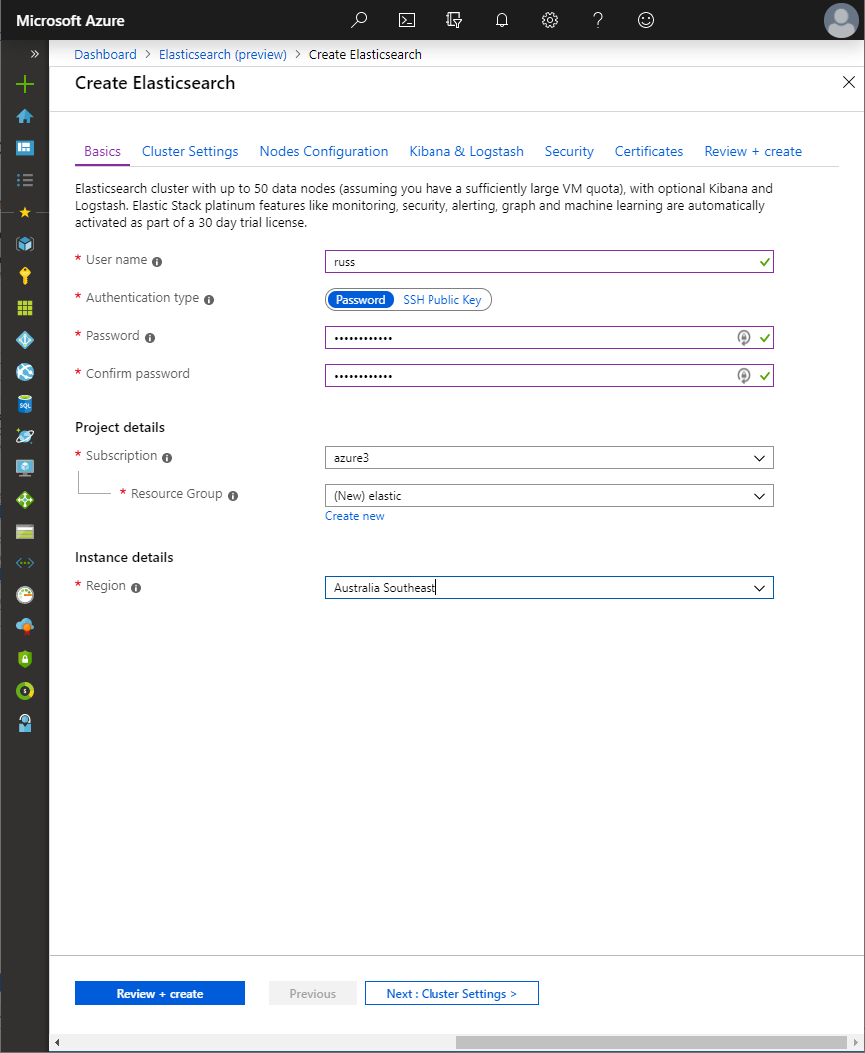
  - Next step is to specify the cluster settings, this option is to pick the version of Elastic search to deploy, give the cluster a name, also give the Vnet and subnet to deploy the stack.
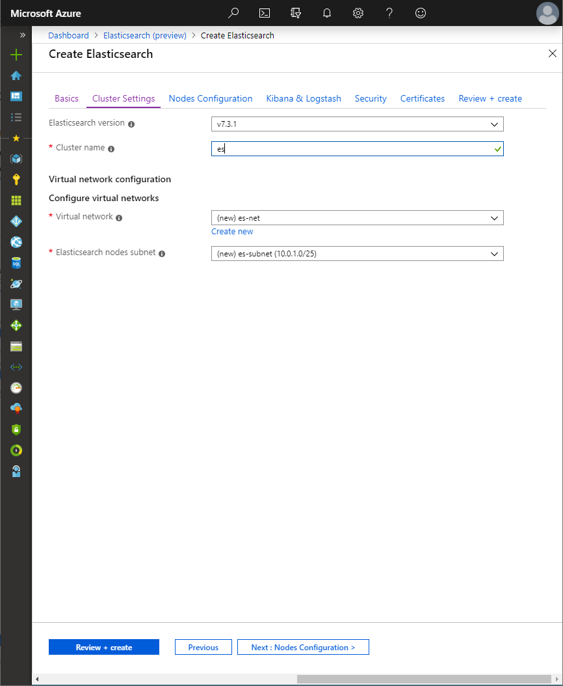
  - The Nodes configuration controls the number and type of node to deploy for the cluster
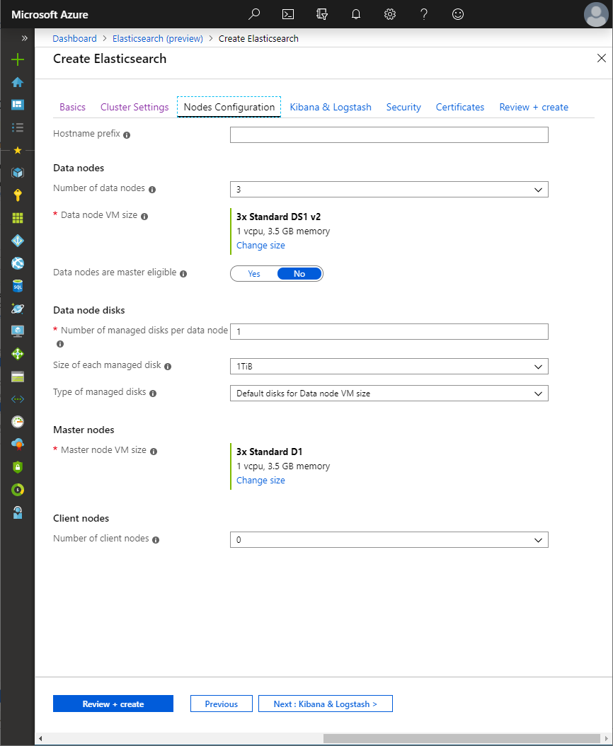
  - The Kibana & Logstash section determines whether to deploy Kibana and/or Logstash in addition to Elastic search, as well as how the cluster can be accessed from outside of the virtual network (load balancer type (external/internal))
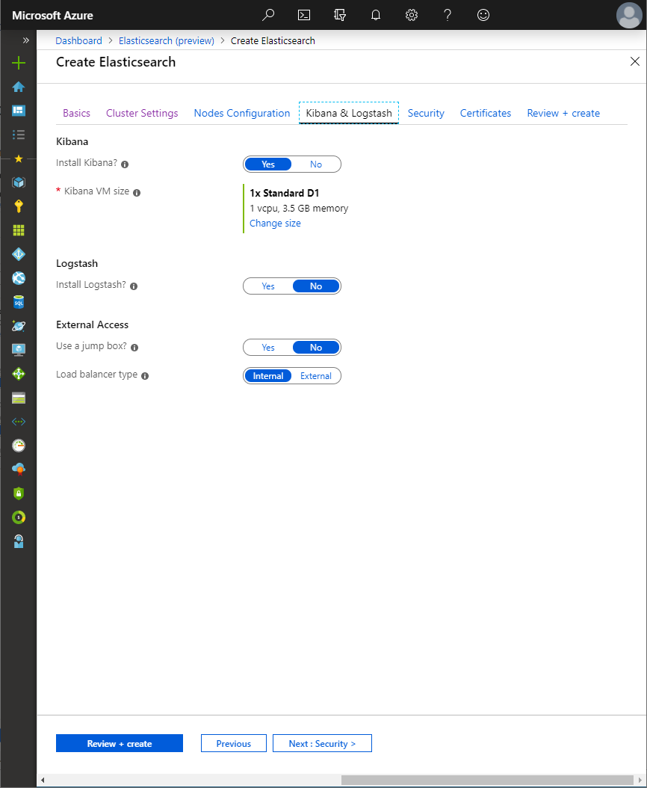
  - Security section refers to authentication for elastic search, Kibana and Logstash.
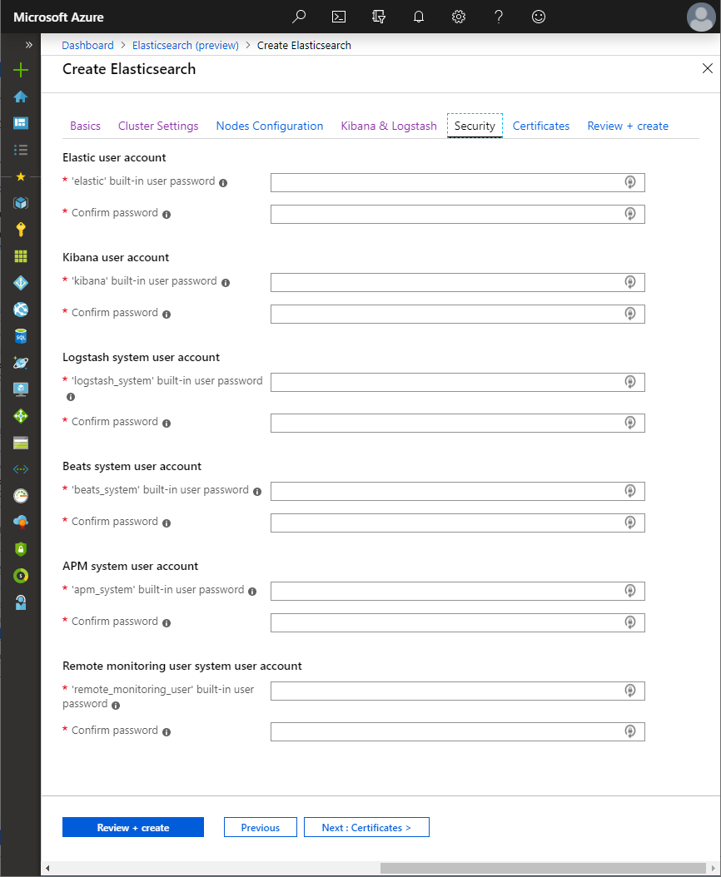

  - Certificate section for Transport Layer Security (TLS) can be configured for both Elastic search and Kibana. We just skipped TLS here test purpose.
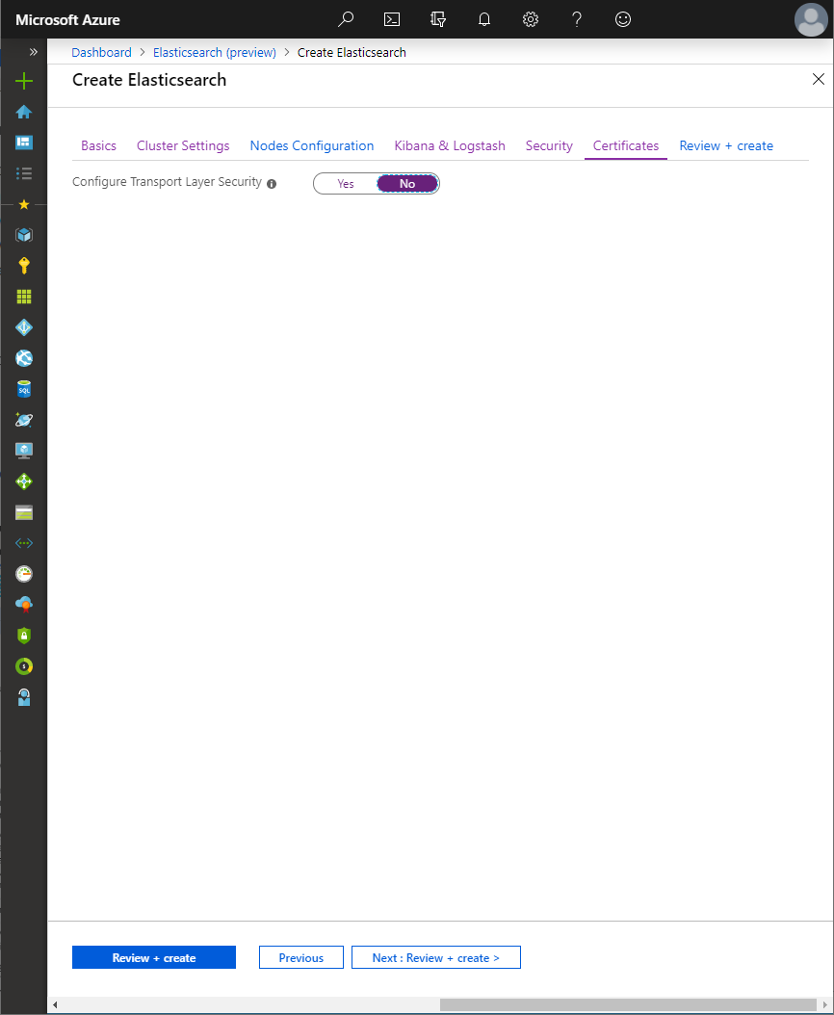
  - The last steps of configuring the deployment allow you to confirm the values provided for all inputs in the previous steps, and to read the terms and conditions before deployment.
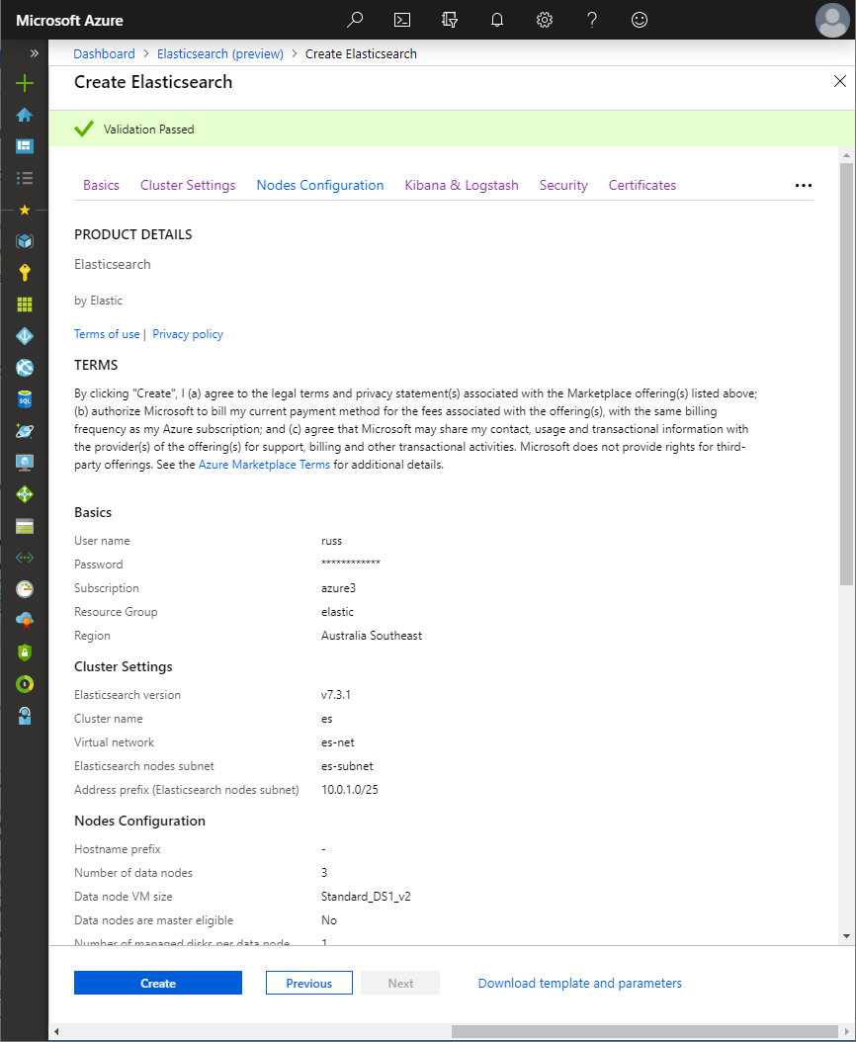
  - Once you verify the summary click on “create”, a new deployment will be started and within minutes, you’ll have Elastic search running on your Azure.

Accessing the resources(Elasticsearch and Kibana):
  - Elasticsearch can be accessed from outside of Azure through the external load balancer, by navigating to the external load balancer public IP address resource along with port 9200
  - And Kibana can be accessed by using either the IP address or public domain name with port 5601. Once you browse for Kibana you will be asked for Username and password. Username will be “elastic” and enter password you have added while deploying the stack. Kibana dashboard will be looks like this.
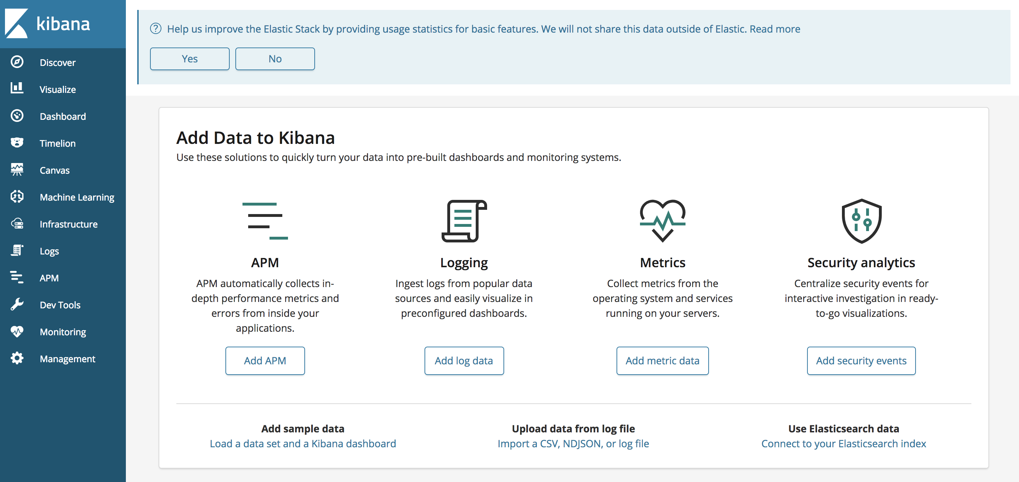
  - Virtual machines can be accessed using SSH through the Kibana VM. Once connected to the Kibana other VMs on the virtual network can be accessed using SSH with either the internal IP address or VM hostname.

Installing and configuring Filebeat and Metricbeat in a Linux server:

Filebeat and Metricbeat are lightweight shippers for forwarding and centralizing log data. Installed as an agent on your servers,
Filebeat monitors the log files or locations that you specify, collects log events, and forwards them to either to Elasticsearch or Logstash for indexing.
Metricbeat takes the metrics and statistics that it collects and ships them to the output that you specify, such as Elasticsearch or Logstash.

Installing and Configuring Filebeat:

- Filebeat can be downloaded and installed using below commands:

- deb:
# curl -L -O https://artifacts.elastic.co/downloads/beats/filebeat/filebeat-7.4.0-amd64.deb

# sudo dpkg -i filebeat-7.4.0-amd64.deb

- rpm:
# curl -L -O https://artifacts.elastic.co/downloads/beats/filebeat/filebeat-7.4.0-x86_64.rpm

# sudo rpm -vi filebeat-7.4.0-x86_64.rpm

- To configure the filebeat we have to edit Filebeat configuration file which is at /etc/filebeat/filebeat.yml. Open this configuration file using vi or nano
- Change the below lines in the configuration file with your values.
output.elasticsearch:
hosts: ["<es_url>"]
username: "elastic"
password: "<password>"
setup.kibana:
host: "<kibana_url>"

Setup.enabled.dashboards: true

Where <password> is the password of the elastic user, <es_url> is the URL of Elasticsearch, and <kibana_url> is the URL of Kibana.

- Filebeat has everything in terms of modules. We have to enable the module for which logs we want to forward to Kibana. Use the command to list all modules in filebeat.
# filebeat modules list

- To enable a particular module use below command.
# filebeat modules enable <module name>
Modify the settings in the /etc/filebeat/modules.d/<module name>.yml file if needed.
- The setup command loads the Kibana dashboards. And start filebeat using following commands.
# filebeat setup
# systemctl start filebeat
- Once the setup has been done we can check logs in the Kibana dashboard.

- Open the Kibana dashboard and navigate to Management.
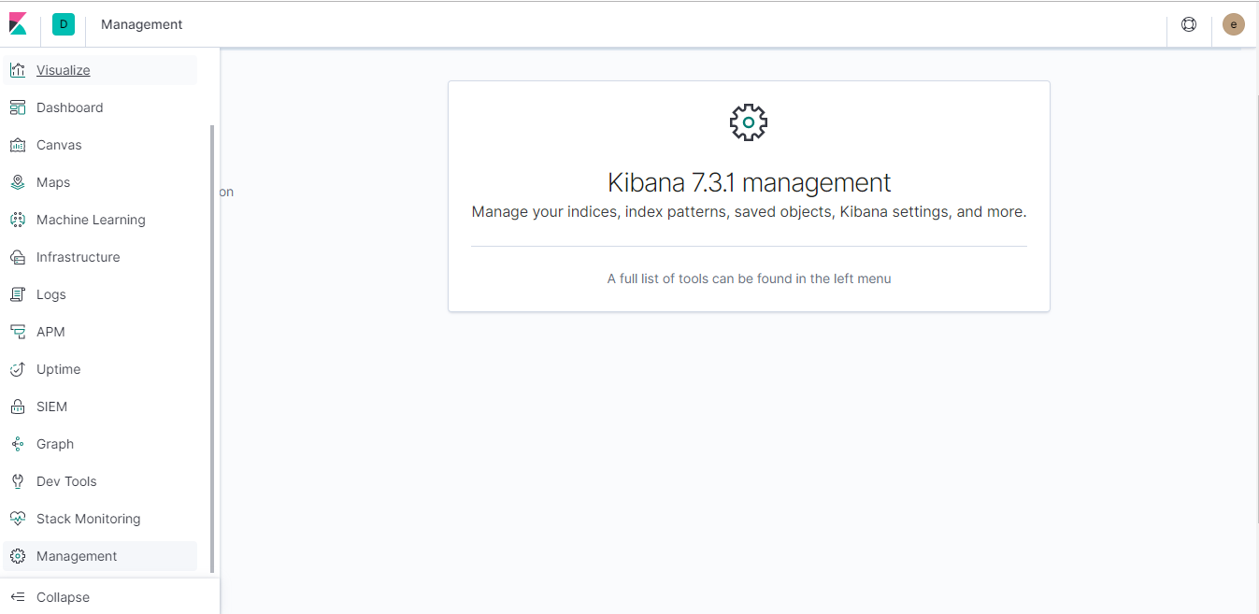

- Now we have to create index pattern to retrieve data from Elasticsearch indices for things like visualizations.
- Go to index patterns and click on “create index pattern”. Give a name and select filebeat which was installed earlier and add field like @timestamp.
- Now, can visualize your logs in the Kibana server by navigating to Visualize section and select you index here.

Installing and Configuring Metricbeat:

- Filebeat can be downloaded and installed using below commands:
- deb:
# curl -L -O https://artifacts.elastic.co/downloads/beats/metricbeat/metricbeat-7.3.1-amd64.deb
# sudo dpkg -i metricbeat-7.3.1-amd64.deb

- rpm:
# curl -L -O https://artifacts.elastic.co/downloads/beats/metricbeat/metricbeat-7.3.1-x86_64.rpm

# sudo rpm -vi metricbeat-7.3.1-x86_64.rpm

- To configure the filebeat we have to edit Filebeat configuration file which is at /etc/metricbeat/metricbeat.yml. Open this configuration file using vi or nano
- Change the below lines in the configuration file with your values.
output.elasticsearch:
hosts: ["<es_url>"]
username: "elastic"
password: "<password>"
setup.kibana:
host: "<kibana_url>"

Setup.enabled.dashboards: tre

Where <password> is the password of the elastic user, <es_url> is the URL of Elasticsearch, and <kibana_url> is the URL of Kibana.

- Metricbeat has everything in terms of modules. We have to enable the module for which logs we want to forward to Kibana. Use the command to list all modules in filebeat.
# metricbeat modules list

- To enable a particular module use below command.
# metricbeat modules enable <module name>
Modify the settings in the /etc/metricbeat/modules.d/<module name>.yml file if needed.

- The setup command loads the Kibana dashboards. And start metricbeat using following commands.
# metricbeat setup
# systemctl start metricbeat
- Once the setup has been done we can check metrics in the Kibana dashboard.
- Open the Kibana dashboard and navigate to Management.

- Now we have to create index pattern to retrieve data from Elasticsearch indices for things like visualizations.
- Go to index patterns and click on “create index pattern”. Give a name and select metricbeat which was installed earlier and add field like @timestamp.
- Now, can visualize your metrics in the Kibana server by navigating to Visualize section and select you index here.

Installing and configuring Filebeat and Metricbeat in Kubernetes cluster (AKS):
Installing and configuring Metricbeat:
- First, we need to install “kube-state-metrics” which is a service listening the Kubernetes API to exposes a set of useful metrics about the state of each Object.
- To install kube-state-metrics, simply run the following command:
# kubectl apply -f https://raw.githubusercontent.com/bethinasudheer/ELK-kubernetes/master/kube-state-metrics.yml
- Verify whether kube-state-metrics is running by using following command
# kubectl get nodes -n kube-system
- Once kube-state-metrics is running we can deploy metricbeat template to AKS. Use following commands.
# curl -L -O https://raw.githubusercontent.com/bethinasudheer/ELK-kubernetes/master/metricbeat-kubernetes.yaml
- Change the following parameters in the manifest file to specify different destination of elasticsearch and Kibana.
- name: ELASTICSEARCH_HOST
value: elasticsearch
- name: ELASTICSEARCH_PORT
value: "9200"
- name: ELASTICSEARCH_USERNAME
value: elastic
- name: ELASTICSEARCH_PASSWORD
value: changeme
- name: ELASTIC_CLOUD_ID
value:
- name: KIBANA_HOST
value: kibana
- name: KIBANA_PORT
value: "5601"
- Now, apply the configuration with following command
# kubectl apply -f metricbeat-kubernetes.yaml

- Wait until the pods are running, you check the status using as following command
# kubectl get pods -n kube-system
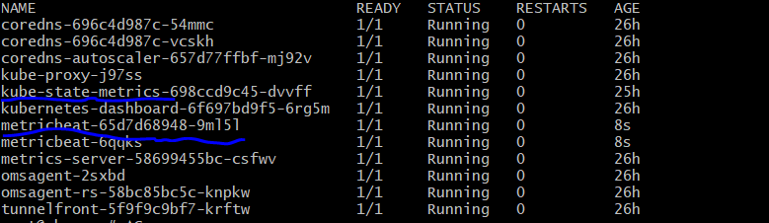
- Once these pods are running we can view the Kubernetes metrics at kibana server.
- Go to Kibana Server and create a index pattern at management -> index pattern -> give a name and select metricbeat*
- Now go to dashboard and select “[Metricbeat Kubernetes] Overview ECS”. Then you would be able to see like this for your AKS.
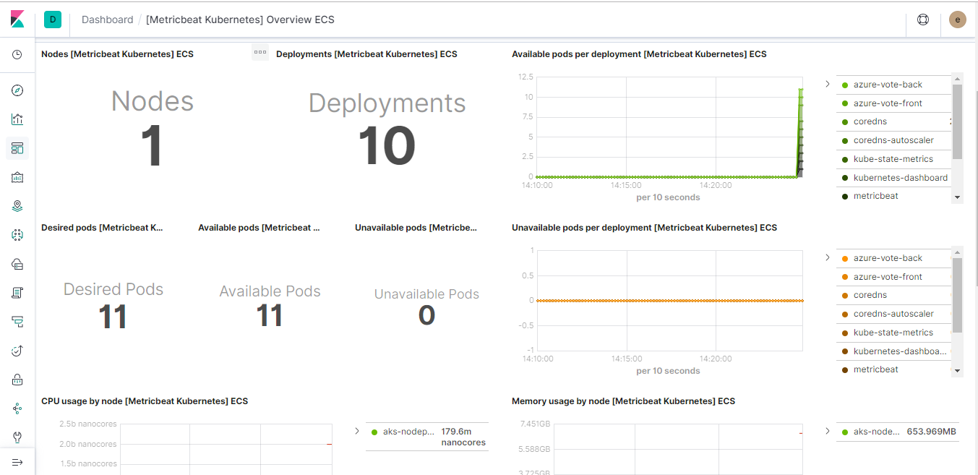

Installing and configuring Filebeat:
- To install filebeat in Kubernetes environment we just have to configure a yaml file for filebeat. Follow below commands to install and configure filebeat in Kubernetes environment.
# curl -L -O https://raw.githubusercontent.com/bethinasudheer/ELK-kubernetes/master/filebeat-kubernetes.yml
- Change the following parameters in the manifest file to specify different destination of elasticsearch and Kibana.
- name: ELASTICSEARCH_HOST
value: elasticsearch
- name: ELASTICSEARCH_PORT
value: "9200"
- name: ELASTICSEARCH_USERNAME
value: elastic
- name: ELASTICSEARCH_PASSWORD
value: changeme
- name: ELASTIC_CLOUD_ID
value:
- Now, apply the configuration with following command
# kubectl apply -f filebeat-kubernetes.yaml

- Wait until the pods are running, you check the status using as following command
# kubectl get pods -n kube-system
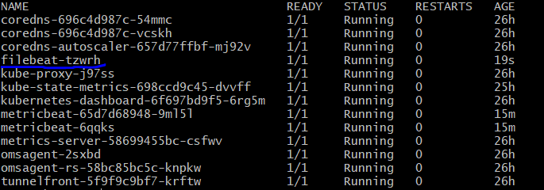
- Once these pods are running we can view the kubernetes metrics at kibana server.
- Go to Kibana Server and create a index pattern at management -> index pattern -> give a name and select filebeat*. Also select field as @timestamp
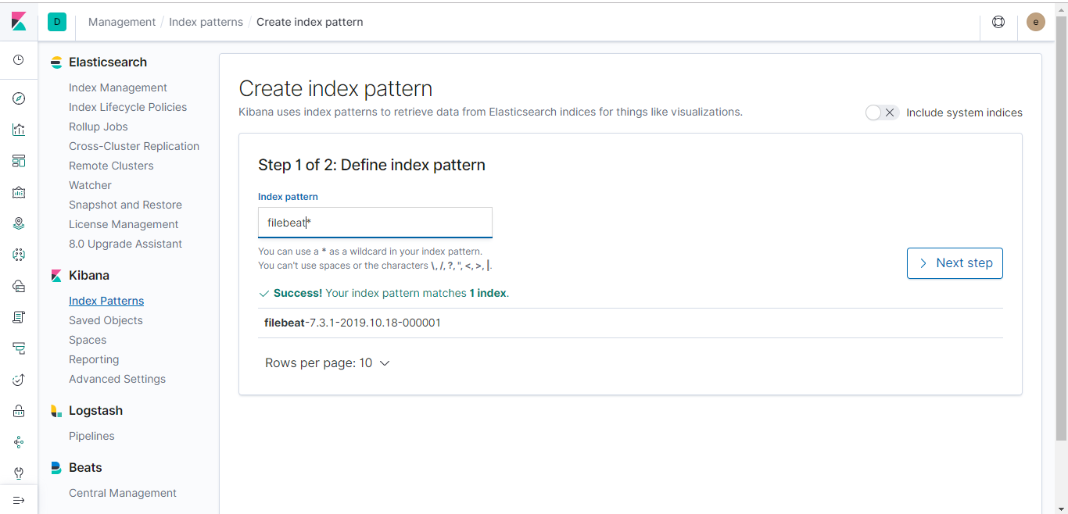
- Now go to “discover” and select index pattern you have created earlier. Then you would be able to see your logs for AKS.
